How to Use Teams

Desktop:

1. Go to the meeting invite and select **Click here to join the meeting**.  
   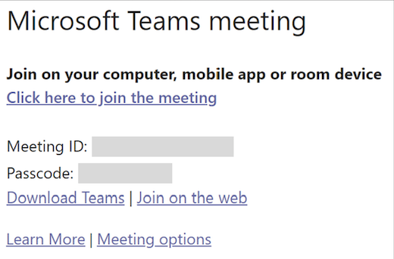
2. That'll open a web page, where you'll see two choices: **Download the Windows app and Join on the web instead.** If you join on the web, you can use either Microsoft Edge or Google Chrome. Your browser may ask if it's okay for Teams to use your mic and camera. Be sure to allow it so you'll be seen and heard in your meeting.
3. Enter your name and choose your audio and video settings. If the meeting room (or another device that's connected to the meeting) is nearby, choose **Audio off** to avoid disruption. Select **Phone audio** if you want to listen to the meeting on your mobile phone.
4. When you're ready, hit **Join now.**
5. If you enter the meeting lobby, wait for someone in the meeting to admit you.

Mobile:

1. In the meeting invite, select **Click here to join the meeting.**
2. If you don't already have the Teams mobile app, you'll be taken to your app store to download it.
3. Download and open the app.

* If you have an Android device, open the app right from the app store page.
* If you have an iOS device, reopen the meeting link to open the app.

Teams will ask if it's okay to use your mic. Be sure to allow it so others in the meeting will be able to hear you.

1. Next, you'll be given two options for joining your meeting: **Join as a guest** or **Sign in and join**. Choose **Join as a guest.**  
     
   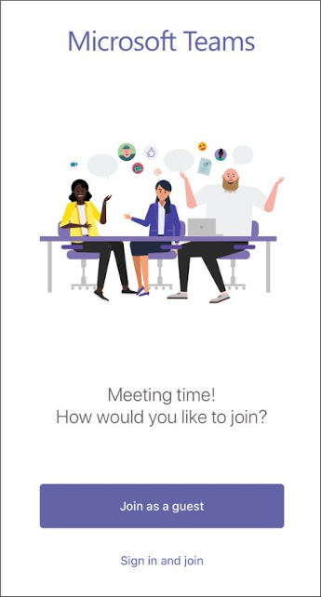
2. Type your name and tap **Join meeting.**  
     
   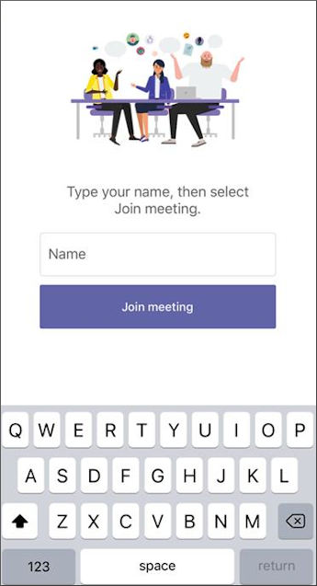  
     
   For the next step, the meeting organizer or their administrator may require you to sign in with an authorized account to join the meeting.  
     
   It may require for you to sign with an authorized account by entering the meeting ID and Passcode that is provided in the link.
3. Depending on how the meeting was set up, you may be able to enter the meeting now.  
     
   ***OR***  
     
   If you see either of the following screens below similar to this, sign in with the mentioned account ***OR*** Sign into an account that was authorized for the meeting

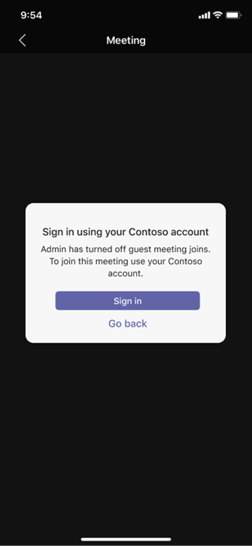 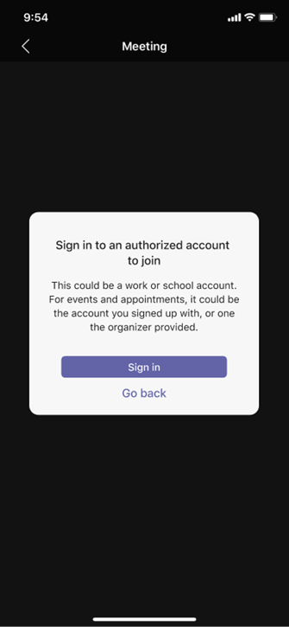

Once you're in the meeting, you can turn your video or mic on or off by tapping on the center of your screen to show the meeting controls. Tap again to hide them.